VOIP lab experiment#7
Creating outbound routes

Installation and Repair of Telecommunications Equipment

Name of student:________________
Group Number:_________________
Date:_________________________

The purpose of the lab is to create an outbound route in PBX. An outbound route is all the external calls, as an example 9.
Go to the outbound route inside the menu connectivity, and enter a route name:
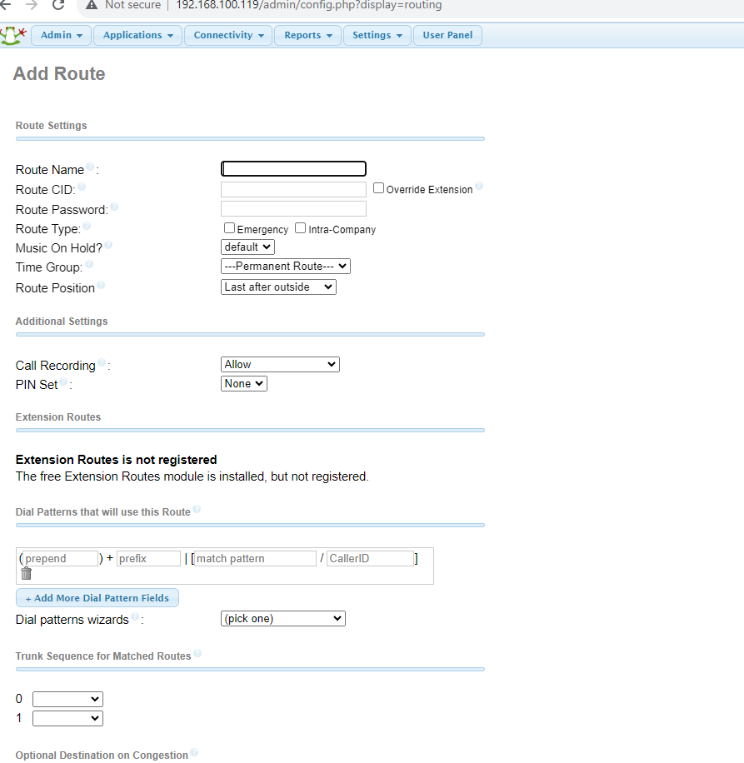
In dial Patterns at the prefix type 9 and match pattern type.
In the trunk sequence for matched routes, choose the trunk that you created.
Submit changes and then click on apply config.

